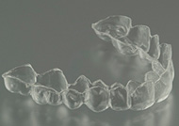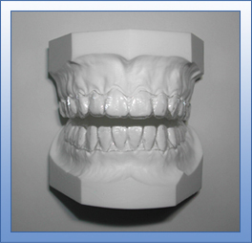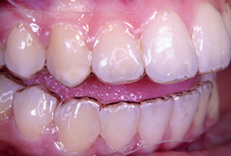
ESSIX

These retainers are designed to maintain the new position of your teeth. They are made of a special heat-molded plastic material. These retainers fit snugly over your teeth, and are removable.

INSTRUCTIONS:

- If a retainer is not worn as directed, it may not fit the teeth properly, even after a few days. A very slight shift of a tooth can make the retainer useless. Please wear it as directed!
- Only night time wear is required, if you have a bonded retainer in place. Please wear the retainer every night for six months. If there is a problem with the retainer bring the retainer and the model back for evaluation. Please bring the retainer with you when you return for each check-up appointment. With your help, we have done our job to get your teeth straight, now it’s your job to help keep them straight!
- After six months, you may start wearing your retainer one night per week, pay attention to the retainer’s tightness. If the retainer feels tight when you first put it in your mouth, you should be wearing it a little more often than one night per week.
- A retainer is an expensive appliance to replace. We cannot hold ourselves responsible for the cost of repair or replacement of the retainer if it is lost or broken through neglect.
- If you lose or break the retainer, please book an appointment with us AS SOON AS POSSIBLE and bring your model, so we can make a new retainer for you. The longer you wait the greater the chance your teeth will shift.
- When you brush your teeth, brush your retainer as well with toothpaste.
- Never use boiling hot water to “sanitize” your retainer, it will permanently destroy it. Do not leave your retainer on dashboards on hot days or sit on it. If you have a dog in the house, keep the retainer out of reach as dogs do use it as a chew toy.

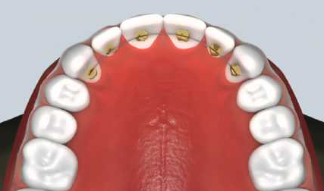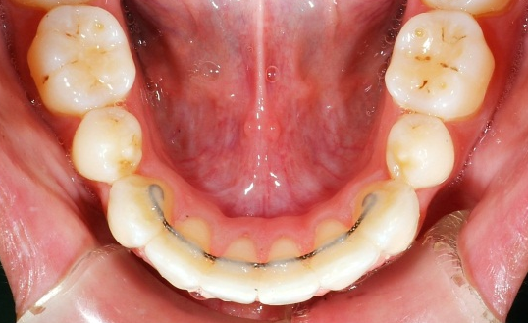
BONDED RETAINER

A Bonded Retainer is glued behind your front teeth and becomes a permanent fixture in your mouth. This retainer will maintain your teeth in their new positions. These retainers are recommended to be in place permanently. Please note that should you decide to remove these retainers there is always a chance that some shifting of the teeth may occur. We therefore cannot hold ourselves responsible for poor maintenance or unretained teeth.

Should any cement/bonding material come off of a tooth or is chipped, it is important to call our office immediately to have it repaired.

It is imperative to clean properly behind your teeth by brushing the area as often as possible. Tartar control toothpastes are essential. Flossing on a daily basis is also crucial and can be done using “floss threaders”. Thread the floss into the loop and pass the threader between the teeth under the wire. Hold onto one end of floss and pull the other end through. Floss between the tooth and gum. Threaders can be reused. Floss threaders are available at larger drug stores.

