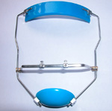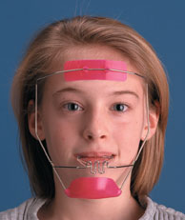

FACEMASK

The Facemask appliance is used to correct skeletal imbalances where the lower jaw is in front of the upper jaw. This correction occurs due to a combined restriction of mandibular growth and an enhancement of maxillary growth. The face mask will attach with rubber bands to the palatal expander. With the sutures mobilized by the expander, the face mask will be used to pull the upper jaw forward and correct the skeletal imbalance of the jaws. The face mask will be worn for 12-15 hours a day until an over-correction of the bite has been achieved (approximately six to nine months).

