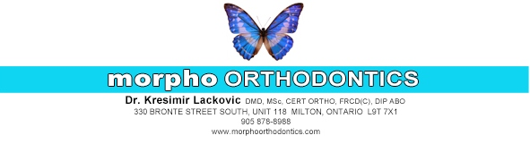
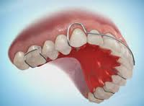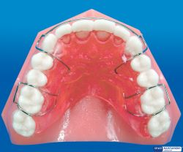
HAWLEY

A Hawley appliance is a removable retainer, consisting of wires and clear plastic. This appliance is used to retain teeth in their new position following orthodontic treatment.

INSTRUCTIONS:

- If a retainer is not worn as directed, it may not fit the teeth properly even after a few days. Even a very slight shift of a tooth can make the retainer useless. PLEASE WEAR IT AS DIRECTED! This usually means full-time, 24 hours per day, unless otherwise specified.

- Retainers should be removed for: eating, tooth brushing, swimming, vigorous Sports

- A retainer is an expensive appliance to replace. We cannot hold ourselves responsible for the cost of repair or replacement of the retainer if it is lost or broken through neglect.

- Keep your retainer clean by brushing it with a bit of tooth paste whenever you brush your teeth. Once a week, the retainer can be soaked in a solution of Polident Retainer Cleanser or a similar agent.

If you are having any trouble, please call our office and we will be glad to help you.

