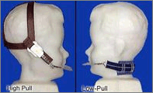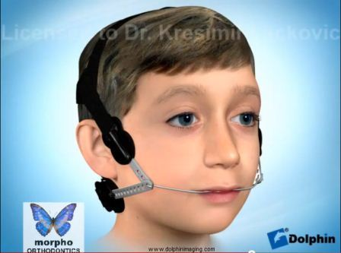

HEADGEAR

A Headgear is a device that helps correct an excessive overbite by placing pressure against the upper teeth and jaw to hold the teeth in position or help move them back into better positions. It can also be used as an “orthopedic” appliance, helping control the growth of the jaws by “holding” the upper jaw and allowing the lower jaw to grow forward. The pressured used and time worn depends upon the severity of the problem. Orthopedic changes take place over an extended time period while the patient is growing. The more it is worn, the more successful treatment result is produced.

Headgear is a device with two parts: a soft strap with elastics attached to it and a metal part (called a facebow), that fits into the bands or onto the arch wires. A headgear adds extra force to the braces as they move the teeth. By using your neck or head as an anchor, the strap or elastic bands produce a steady pressure that gradually aligns the protruding upper jaw and teeth with the lower jaw and teeth. The headgear can work by slowing the growth of the upper jaw, allowing the lower jaw time to catch up.

The more it is worn the faster the teeth move. Dr. Kresimir Lackovic will recommend the correct number of hours. Usually it is worn 14 to 16 hours each day, this means at night when you sleep, plus after school and on weekends at home. If it is not worn enough on one day, the time must be made up on the next day. Once headgear treatment is started, it must be adhered to continuously. The key to success with your headgear is consistency.

The headgear should never be worn during any active sport or activity such as swimming, soccer or dancing. It should be removed while eating or brushing your teeth.

If the bands on the molar teeth become loose, call our office immediately. Please bring your headgear to every adjustment appointments.

Please visit our website for an instructional video:

http://www.morphoorthodontics.com/types-of-appliances

