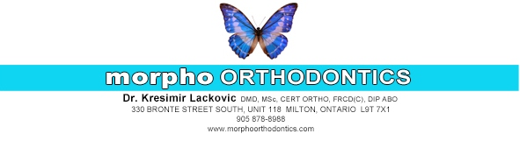
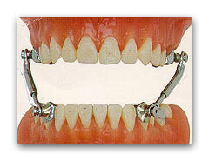
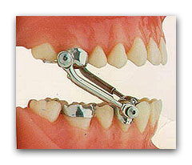
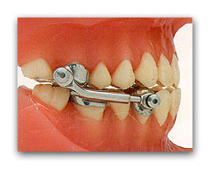

HERBST APPLIANCE

The Herbst appliance is used to correct the front-to-back relationship of the upper and lower jaws. The expander on the roof of your mouth is used to make the top jaw bone wider. The rod and tubes connects the upper and lower jaws and applies the force to move the jaws and teeth in opposite directions. This really does not interfere with opening and closing your mouth or with eating. You might find that side to side movement is somewhat restricted.

THINGS YOU WILL NEED TO GET USED TO:

- The expander on the roof of your mouth will make pronunciation difficult. With practice you will adjust and be speaking normally on average within a week’s time. Practice speaking at home as much as possible.
- The bottom screws may irritate your lip. Your lip will toughen up like a callous but it will take a few days for it to happen. You can put Orabase on the inside of the lip or cheek where it is sore. You can also place wax over the screws to make it smoother.
- When the lower jaw is brought forward the back teeth do not come together like they did prior to the placement of the appliance. Those teeth will come together soon, so be patient.
- Your teeth will be sore after the Herbst appliance and braces are placed. This initial soreness will typically last 24-48 hours or in some people even longer. The soreness will go away and be felt again after each adjustment visit. If the pain/soreness is unbearable, then take whatever you normally take for headaches. Ibuprofen has been found to work the best. Examples include Advil or Motrin. Take as directed on the bottle.

POSSIBLE PROBLEMS:
- If you open very wide sometimes the rods and tubes can pop apart. If they do, just open wide and put the rods and tubes back together. If you cannot get them together, then you can leave them apart and call for an appointment for us to put them back together again. If the rods and tubes have come apart and are not causing pain, they can wait to be put back together the next day, or if over the weekend, until Monday. If they are causing pain, call the office and we will put them back together as soon as possible. If you are having a problem with the rods and tubes disengaging/unscrewing often, please call the office and we will replace them.
- Occasionally a screw may come loose; if this happens then you will have a rod or tube dangling from your mouth. If this is causing pain then call our office and we will reattach the rod and tube. If it is not causing pain then it can wait until the next day or if over the weekend until Monday. You may attempt to screw it in yourself. Do not tighten the screws unless it has come loose.
- Infrequently the Herbst can come loose or break; any appliance that is put in your mouth can be broken. Breakages do occur and are a part of life, no appliance is indestructible. If you have a problem with something coming loose or have noticed something broken please contact the office. If it is not causing you pain and you can function; you can wait until the next day or if over the weekend until Monday. However, if you cannot function normally or there is pain, please contact the office and will correct the problem as soon as possible.

Rapid Palatal Expander Turn Calendar

Please check off each day a turn was completed as directed by Dr. Lackovic. Please bring this calendar to your next appointment.

Sunday | Monday | Tuesday | Wednesday | Thursday | Friday | Saturday

Please visit our website for an instructional video: http://www.morphoorthodontics.com/types-of-appliances

