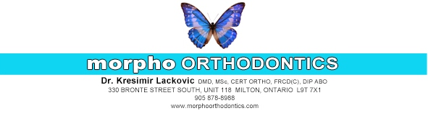
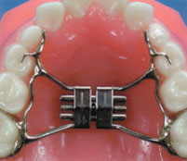

RAPID PALATAL EXPANDER (RPE) & BITEBLOCK

This appliance widens the upper jaw by separating the midpalatal suture. This procedure also allows for the creation of more space for the eruption of the permanent teeth. This appliance is bonded (glued) to the posterior upper teeth (molars).In addition to the RPE, you have received a removable Bite Block appliance.

There are a few simple things to remember about the Bite Block.
- If it is not worn as directed, it may not fit the teeth properly even after a few days. Even a very slight shift of a tooth can make the Bite Block useless. PLEASE WEAR IT AS DIRECTED! This usually means full-time, 24 hours per day, unless otherwise specified.However, the Bite Block should be removed for: eating, tooth brushing, swimming, vigorous sports.
- A Bite Block is an expensive appliance to replace. We cannot hold ourselves responsiblefor the cost of repair or replacement if it is lost or broken through neglect.
- Keep your Bite Block clean by brushing it with a bit of toothpaste whenever you brushyour teeth. Once a week, the Bite Block can be soaked in a solution of denture cleanseror a similar agent.
- Speaking with a Bite Block is relatively easy with a little perseverance and patience in thefirst day or two.

THINGS YOU WILL NEED TO GET USED TO:

- Your teeth will be sore/tender after the appliance is placed. This initial soreness/tenderness will typically last 24-72 hours or in some people even longer. The soreness will go away and be felt again after each adjustment visit. If the pain/soreness is unbearable, then take whatever you normally take for headaches. Ibuprofen has been found to work the best. Examples include Advil or Motrin. Take as directed on the bottle.
- The expander on the roof of your mouth will make pronunciation and eating difficult. With practice you will adjust and be speaking normally on average within a week’s time. Practice speaking aloud at home as much as possible.
- Food may accumulate between the roof of the mouth and the appliance. Try dislodging the food by swishing around a mouth full of your drink or with a proxybrush. It is very important that the space between the appliance and the roof of the mouth be cleansed. If food particles remain under the appliance, it may become a source of irritation and extreme circumstances may cause infections.

POSSIBLE PROBLEMS:

- If the appliance becomes loose, there is pain or extreme breath odor, call the office immediately.
- When brushing, please pay attention to the margin where the appliance meets the gums on the cheek side and tongue side. Improper brushing can leave heavy plaque buildup, causing gingivitis. If you notice the gums are bleeding during brushing, this is a sign of gingivitis. This can be eliminated within 2-4 days with adequate plaque removal when brushing.

Rapid Palatal Expander Turn Calendar

This appliance is activated by inserting the key into the hole at the midline of the appliance and pushed back towards the throat until the next hole becomes visible. The key should be removed by pulling downward. Do not deactivate the appliance by pulling the key forward and out, this will close the next hole needed for the next turn.
Please check off each day a turn was completed as directed by Dr. Lackovic. Please bring this calendar to your next appointment.

Sunday | Monday | Tuesday | Wednesday | Thursday | Friday | Saturday

Please visit our website for an instructional video: http://www.morphoorthodontics.com/palatal-expander

