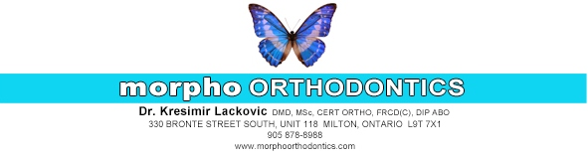
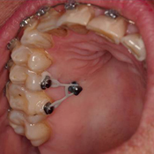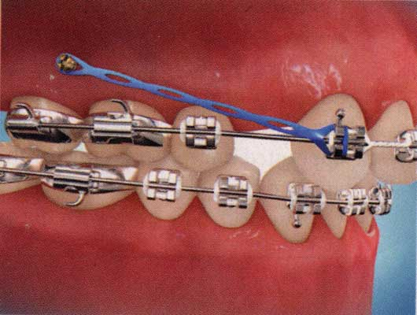

MICROIMPLANTS

Temporary Anchorage Devices (TAD) are mini-implants made of a bio-compatible titanium alloy which are inserted into specific places in the mouth to be used as a fixed point from which teeth can be moved.

POST-OPERATIVE INSTRUCTIONS:

- Use prescribed mouth rinse (Peridex™): Rinse for 30 seconds, twice daily (morning and night, after meals) for two weeks. Do not eat or drink for 1 hour after rinsing.
- It is common to have some soreness in the tissues surrounding the sites of implants, and typically persists for two days, but may last longer. After the implant placement, take an anti-inflammatory and analgesic (pain) medication, such as Advil or Tylenol as needed. Please follow the instructions on the bottle
- Tissue irritation around implants is made worse by smoking, or eating spicy foods. If swelling, throbbing pain, difficulty in swallowing or fever develops and appears to be associated with the implants, please call our office immediately.
- Occasionally, an implant may become loose, and will need to be removed or replaced. Please call our office if you notice a loose implant immediately.
- Please brush the implant and surrounding area with a soft-bristle toothbrush. By keeping the area clean it reduces the chance of an infection tremendously. Using water-irrigating devices, such as Water-Pik, is helpful as well.

